**How to Add a SSL/TLS Certificate to Goliath**

Goliath Performance Monitor and Goliath Application Availability Monitor use Microsoft IIS as their web server. By default, the technologies ship with a self-signed certificate. This article will review how to add a SSL/TSL certificate to the web server.

**What you'll need:**

1. RDP or Console Access to the Goliath Server
2. IIS Web Server Certificate (.pfx)
   1. This can be a wildcard certificate used by your organization or one specific to the Goliath Server

**Instructions:**

1. Connect to the Goliath Server via RDP or Console
2. Place the IIS Web Server Certificate somewhere on the system
   1. The location of this file will be needed in a later step
3. Launch "Internet Information Services (IIS) Manager"
   1. This can be done by clicking on the "Start" menu, and then "Administrative Tools" or also by going to "Tools" inside Server Manager
4. Once IIS Manager is open, click on the hostname of the machine in the left hand "connections" frame
   1. 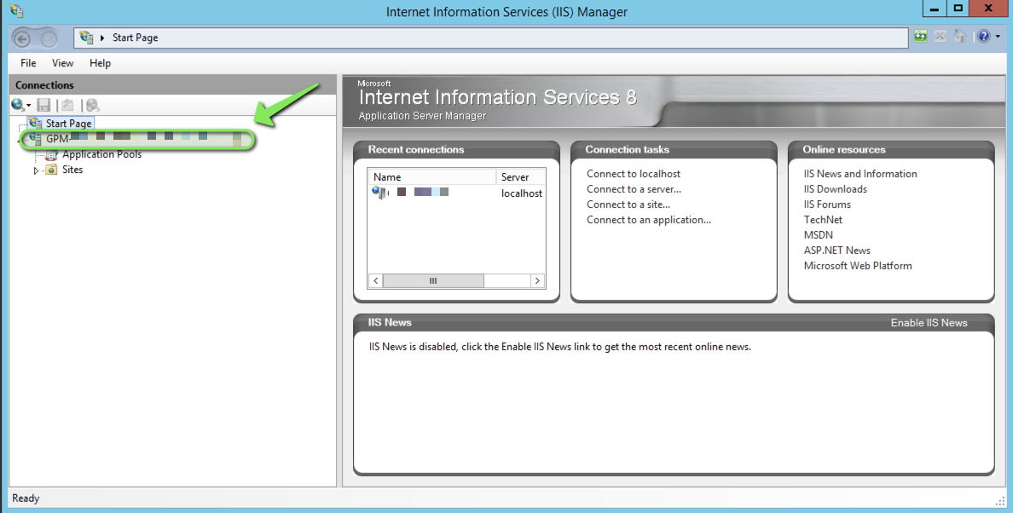
5. In the middle section of the tool, double click on "Server Certificates
   1. 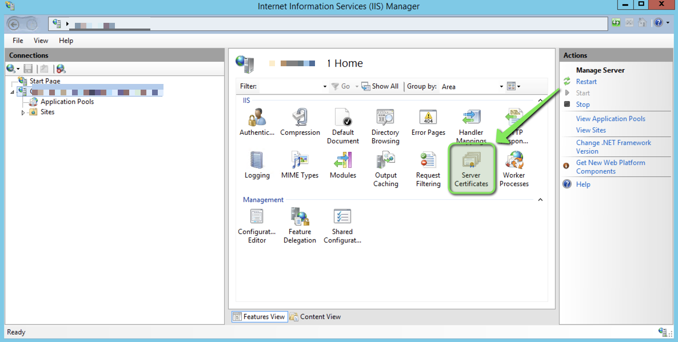
6. Once in the "Server Certificates" view, click on the option "Import" from the "Action" pane on the right hand side
   1. 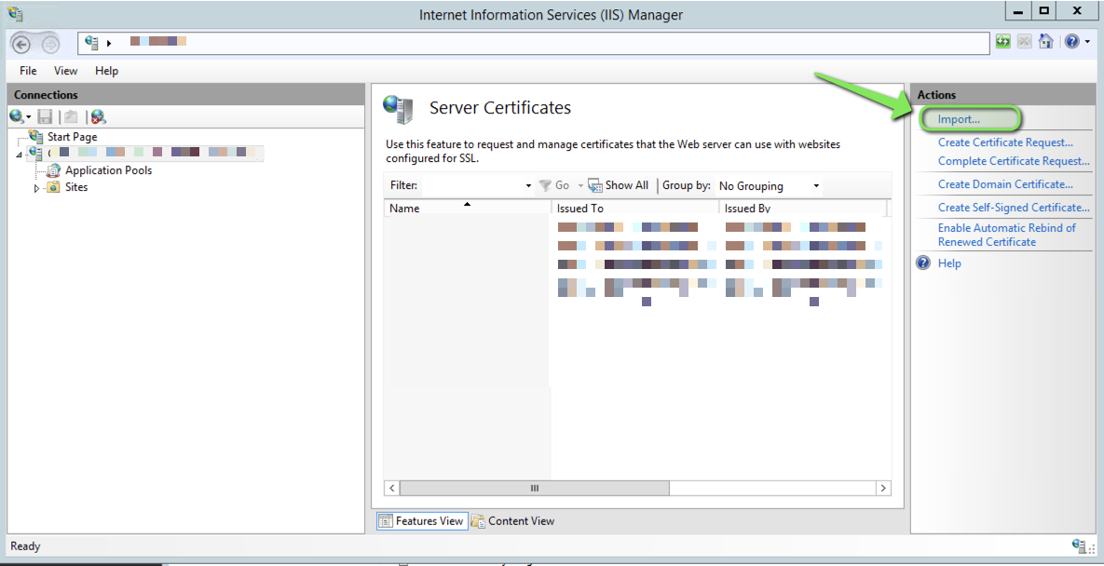
7. A new window will appear, complete the fields for importing the certificate by 1) entering the path to the .pfx location and 2) entering the password for the .pfx file. Feel free to disable "allow this certificate to be exported" is desired. Click "ok" when finished to save and close the window.
   1. 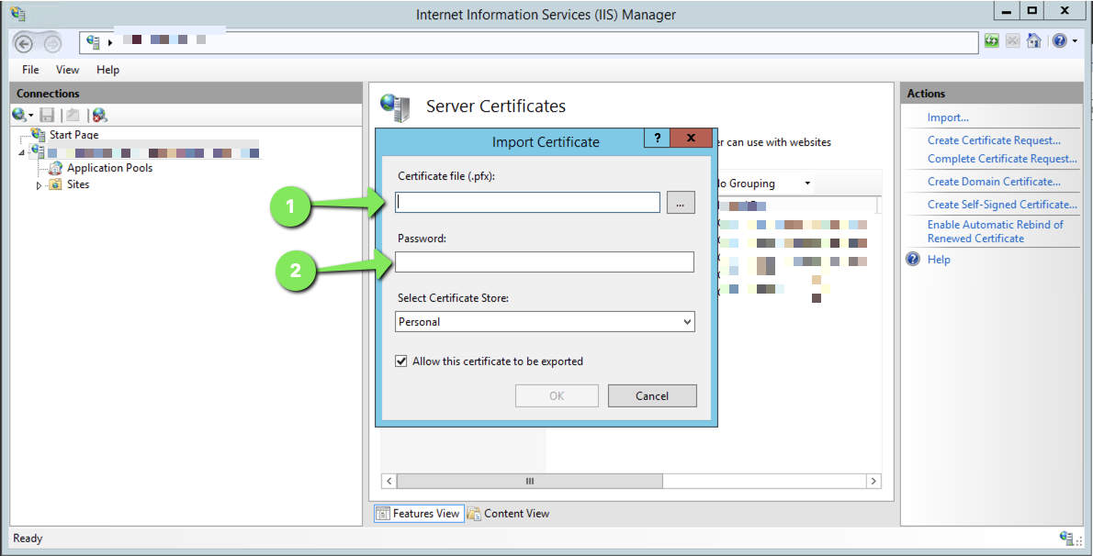
8. You should now see the certificate listed on the "Server Certificates" page.
9. Now that the certificate has been imported, we'll next need to apply it to the website
10. From the left hand "Connections" pane, expand the folder "Sites" and select the site named "GoliathWeb"
    1. 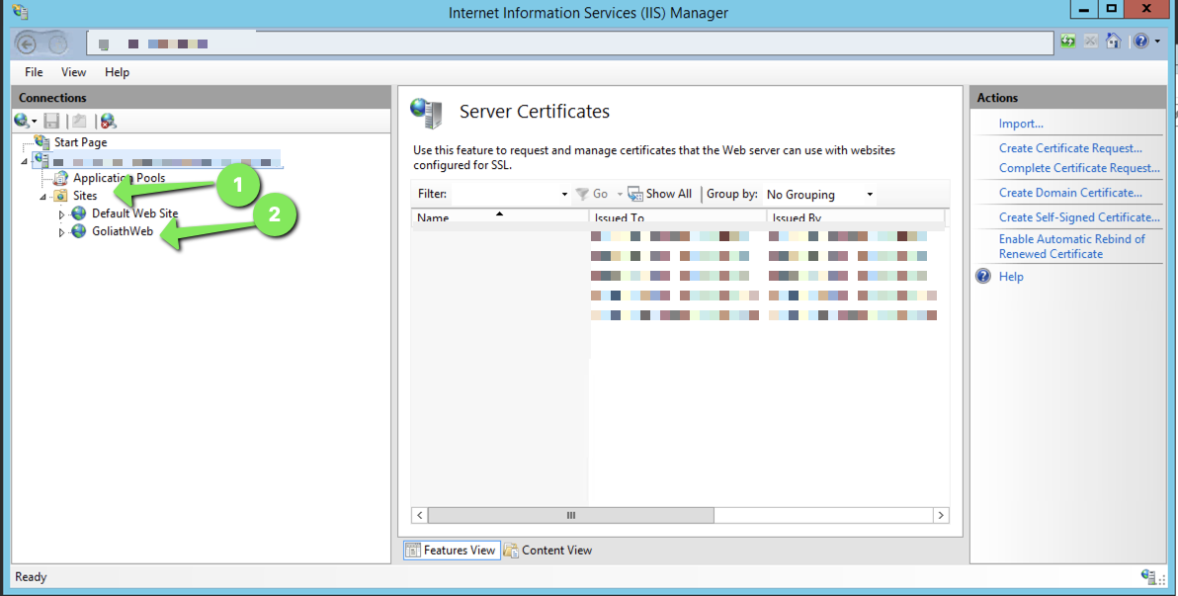
11. From the right hand "Actions" pane, under "Edit Site" click the link for "Bindings..."
    1. 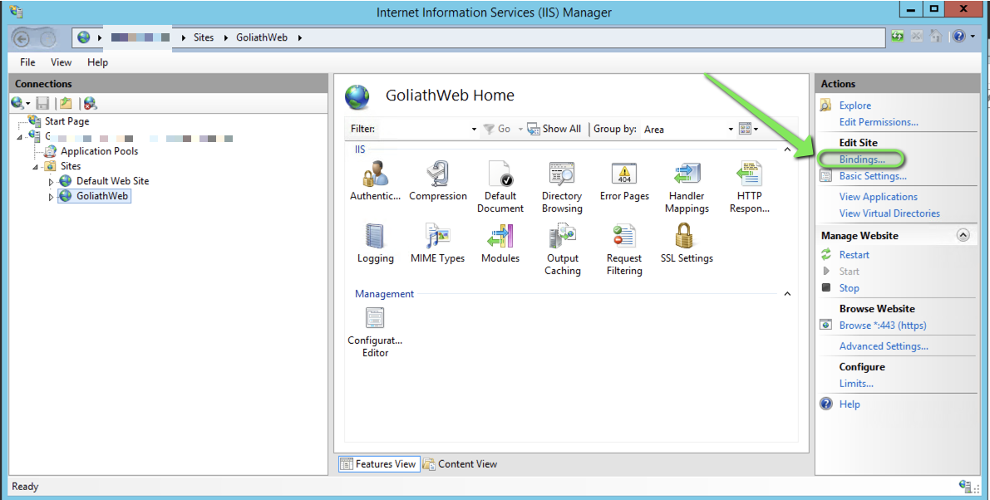
12. A new window will appear, select the site binding and click the "Edit..." button
    1. 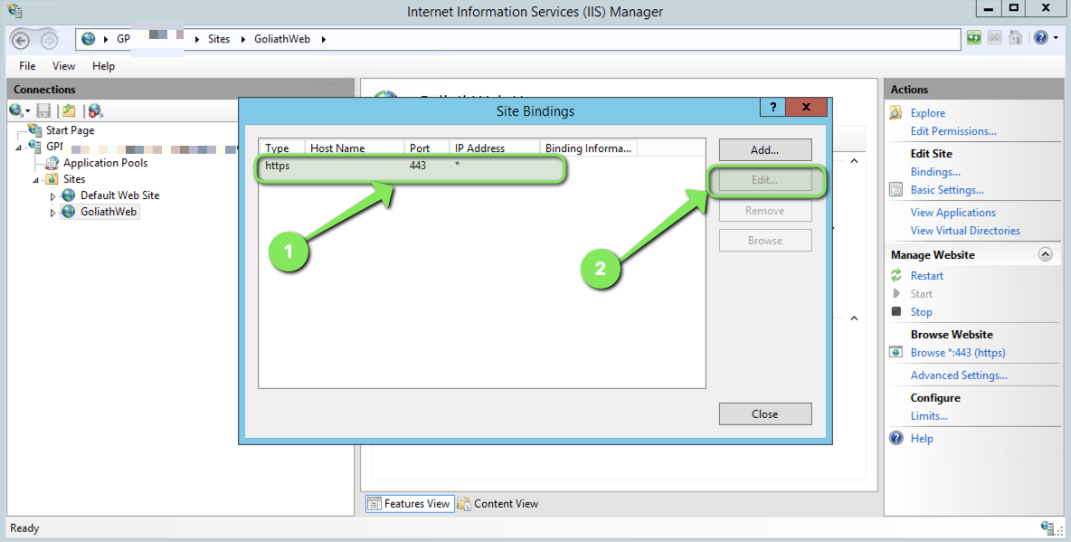
13. Another window will open, use the "SSL certificate" dropdown menu to chose the correct certificate and then click "OK" to close this window.
    1. 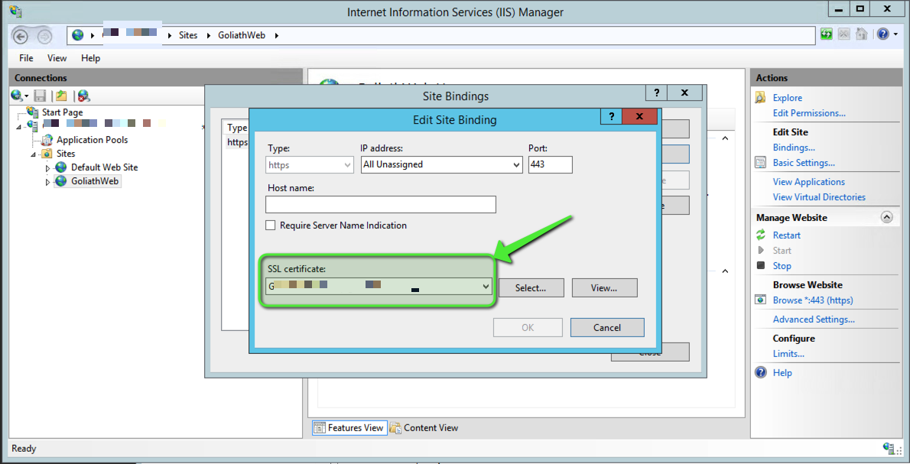
14. Click "Close" to close the other window.
15. From the right hand "Actions" pane, under "Manage Website" click the link for "Restart" to complete the configuration
    1. 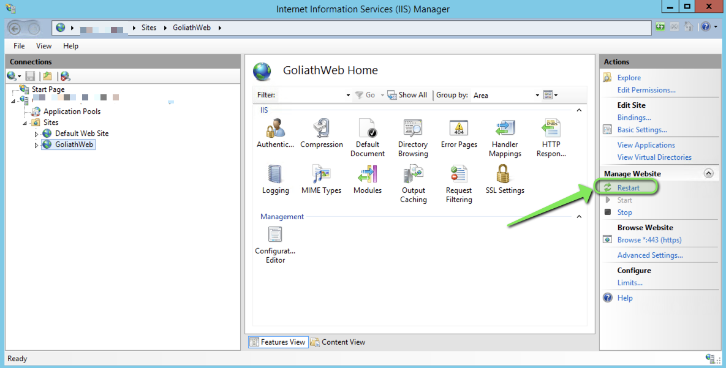
16. Open web browser and now navigate to the secure site url, you should see the Goliath console load and the connection is secure.